**SOLLPM1 Summarized Parts**

Group 2

**Instructions**

1. Summarize each part from the brainstormed infos last meeting (image below)

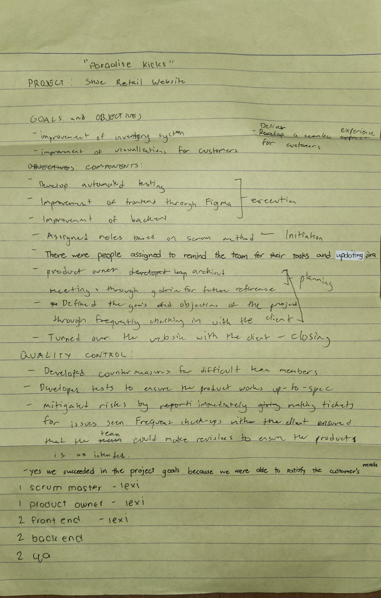

2. Edit the ppt and make the infos shorter than the summarized version

3. 10-15 minutes presentation with Q&A

**Pertinent Links**

| **Description** | **Link** |
| --- | --- |
| Canva Link | <https://www.canva.com/design/DAGcpa-OZcg/uhB_GYquECBXYXS1WhK0aQ/edit?utm_content=DAGcpa-OZcg&utm_campaign=designshare&utm_medium=link2&utm_source=sharebutton> |

**Dates to Remember**

| **Description** | **Date** |
| --- | --- |
| Internal Deadline for Summarized Parts | January 20, 2025 (Monday, 11:59 pm) |
| Internal Deadline for PPT | January 21, 2025 (Tuesday, 11:59 pm) |
| Presentation Day | January 25, 2025 (Saturday, F2F) |

**Flow of Information**

**Project Overview [LEXY]**

**LEXY:** So since this part was already discussed last meeting, we’re just going to have a quick recall of what Paradise Kicks is all about. It is an online shoe reseller which is for individuals who are into sneakers and also to everyone who just wants to buy their desired footwear to their loved ones.

As our group mentioned last Saturday, the said client wanted an application that caters product selection, self-checkout, order tracking, and an improved inventory management system.

🫡✍️😊🎶🫠

To give you a preview of the website, we provided some recordings to visualize the application’s features.

**Goals and Objectives [ROB]**

**ROB:** As for the Goals and Objectives of this project, as Lexy said, the group wanted to:

* Develop an online platform catering to shoe lovers and people purchasing footwear as gifts for their loved ones.

To do this, they needed to:

* Enhance the user experience by implementing features such as
  + product selection, (ease of browsing through different categories and ease of searching for their desired product, also involves sorting the products by different categories like by price. This would also involve getting to choose the product by available colorways or sizes)
  + self-checkout, (this involves payment through different payment channels, though the website as it is now only redirects you to the seller’s messenger)
  + order tracking, (similar to how you track in shipping sites like dhl)
  + and on the admin-side, an improved dashboard for the store’s inventory management system. This is to streamline the inventory management process for efficient stock monitoring and updates.

These goals and objectives guided the team in creating a functional website for Paradise Kicks within the quality expectations and time frame agreed upon by both the team and the client.

**Project Component and Roles [LEXY]**

**LEXY:**

* For initiating, the roles were assigned to all the members.
* These roles include: 1 Product Owner, 1 Scrum Master, 2 Developers, 2 Designers, and 2 QAs.
* For the project, my roles were Product Owner and Designer.
* Was challenged midway because our scrum master that time did not handle our JIRA well.
* Then, to formally start the project, a meeting was held together with the members as well as the client.
* For planning, meetings were still held after the introduction in order to have a discussion in planning the implementation as well as to discuss the goals and the objectives.
* For executing, the developers and designers worked together in order to develop the backend and frontend of the website and consulting the progress with the client.
* For controlling, QAs did the automated testing and updated the defect report if there’s anything that needs to be fixed.
* Lastly, for closing, the team turned over the website to the client.

**Quality Controls, Risk and Communication Plan/Strategy [RYU]**

**RYU:** This part is crucial for project management as this stage ensures a stable and consistent approach when dealing with numerous tasks to further improve the quality and assurance of the project with little to no fail. To specify, this stage provides a structured approach to address potential challenges and ensure the delivery of the product or service to the consumer is successful.

* Developed countermeasures for difficult team members
  + The group also had communication problems with their own team members that have not contributed to the work. This conflict arose when one team member initially assigned the Scrum Master, one that overlooks the project as well as manages the team, was not responding to the group. This in turn was a major conflict as they had to distribute their roles in a broad way where some people had 2 or 3 roles in the team. By dividing their roles and responsibilities they managed to handle the team morale as well as the consistency of work.
* Developed tests to ensure the product works up-to-sync
  + The Quality Assurance (QA) role works closely with the programmers to test the website for bugs and holes that need to be fixed before closing the product (website) to the company. Additionally, pull requests were used by the developers when overwriting and adding additional features to the website’s functionality to provide a thorough update on the usability.
* Mitigation of risks using issue tickets and frequent check-ups
  + The group utilized issue tickets to manage and solve certain issues that needed to be fixed to provide a history of solved and unsolved issues in a stored and organized way. Additionally, this system allows for a consistent work flow by mitigating error escalations and to allow the team to stay on track by checking the ticket records.

**Did you succeed? [DERK]**

**DERK:**

Yes, we were able to succeed in this project because of the following criteria:

* Achievement of Goals
  + We successfully achieve the project's goals by improving their inventory system, improving visualization of the products for the customers, and delivering a seamless and user-friendly experience.
* Timeliness
  + The project was completed on time despite encountering some challenges with time management.
* Quality of Output
  + The final product met the quality standards expected by the client and the project team.
* Impact and Value
  + The project delivered the intended value needed by the client for its customers and company. This included streamlined product selection, self-checkout, order tracking, an improved management system, and an enhanced admin dashboard.
* Team Satisfaction
  + Most team members were satisfied with their roles, although some were unable to complete their assigned tasks. Despite this, we successfully completed the project as a team.
* Risk Management
  + Risks were effectively managed using issue tracking through GitHub tickets. When risks occurred, the team worked collaboratively to address and resolve them as soon as possible.